
a
Company
Logotype

Cone Beam Computed Tomography- Report



Porur Dental X-rays & CBCT

Patient Name : Mr. Sathish Kumar | Date of Report : 27.07.2024
Age/ Gender : 39 years/ Male | Region of Interest : CBCT Maxilla
Referring doctor: Dr. Suchitra Mohan | Indication : Assessment of Maxillary sinus
Clinical Notes: Nil
PATIENT INFORMATION

CBCT- Maxilla provided
CBCT – IMAGE DETAILS

RADIOGRAPHIC INTERPRETATION

- The maxillary alveolar ridge is present with normal trabecular pattern.
- In 21, presence of hyperdense crown and hyperdense restorative material involving the pulp canal extending upto to the apical third of the root is evident.
- In 36, hyperdense restorative material involving the pulp canal extending upto to the apical third of the root is evident.
- Horizontally impacted tooth: 38
- The left maxillary sinus is present with a hyperdense area of mucosal thickening along the floor and involving the anterior wall, medial and lateral walls of the sinus.
- The right maxillary sinus is present with hyperdense calcified structures along the floor of the sinus.
- However, the nasal passage in relation to the right side appears to be narrow and compromised compared to the left side.

RADIOGRAPHIC IMPRESSION

- Root canal treated: 21, 36
- Antrolith: right maxillary sinusitis.
- Left maxillary sinusitis.

Kindly correlate with clinical findings


IMAGES FOR REFERENCE

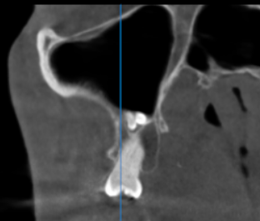
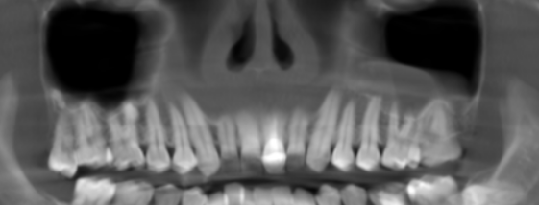
RECON STRUCTED PANORAMIC VIEW

Right and Left maxillary sinus
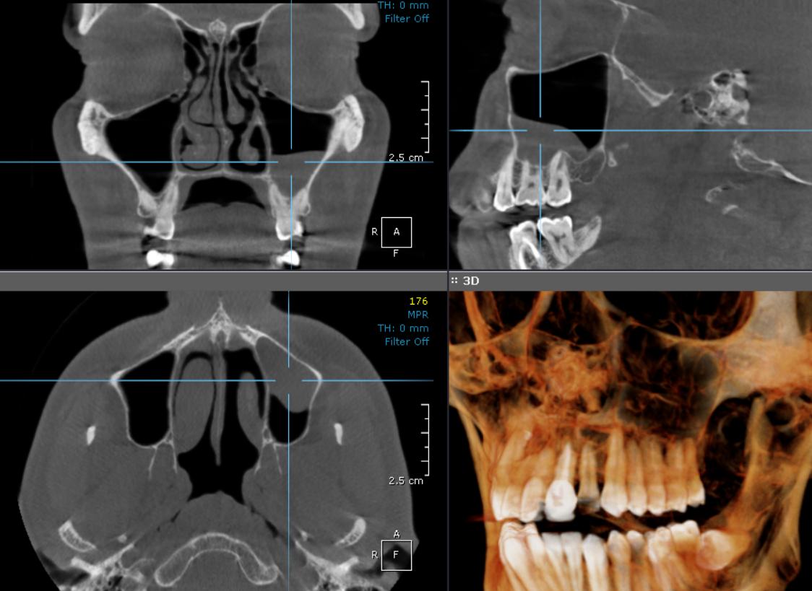

**** End of report ****

